1. How many objects of a servlet is created?

Only one object at the time of first request by servlet or web container.

1. What is the life-cycle of a servlet?

The web container maintains the life cycle of a servlet instance. Let's see the life cycle of the servlet:

1. Servlet class is loaded.
2. Servlet instance is created.
3. init method is invoked.
4. service method is invoked.
5. destroy method is invoked.

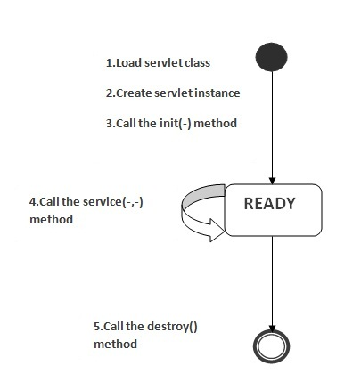

As displayed in the above diagram, there are three states of a servlet: new, ready and end. The servlet is in new state if servlet instance is created. After invoking the init() method, Servlet comes in the ready state. In the ready state, servlet performs all the tasks. When the web container invokes the destroy() method, it shifts to the end state.

1. What is the advantage of servlet?

Advantage of Servlet

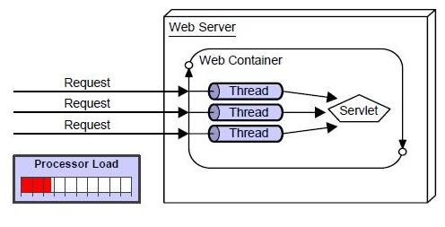

There are many advantages of servlet over CGI. The web container creates threads for handling the multiple requests to the servlet. Threads have a lot of benefits over the Processes such as they share a common memory area, lightweight, cost of communication between the threads are low. The basic benefits of servlet are as follows:

1. **better performance:** because it creates a thread for each request not process.
2. **Portability:** because it uses java language.
3. **Robust:** Servlets are managed by JVM so we don't need to worry about memory leak, garbage collection etc.
4. **Secure:** because it uses java language..

### What is the disadvantage of servlet?

1. Designing in servlet is difficult and slows down the application.
2. Writing complex business logic makes the application difficult to understand.
3. You need a Java Runtime Environment on the server to run servlets.

### What are the life-cycle methods for a servlet?

Servlet class is loaded

The class loader is responsible to load the servlet class. The servlet class is loaded when the first request for the servlet is received by the web container.

Servlet instance is created

The web container creates the instance of a servlet after loading the servlet class. The servlet instance is created only once in the servlet life cycle.

init method is invoked

|  |
| --- |
| The web container calls the init method only once after creating the servlet instance. The init method is used to initialize the servlet. It is the life cycle method of the javax.servlet.Servlet interface. Syntax of the init method is given below: |

**public** **void** init(ServletConfig config) **throws** ServletException

service method is invoked

The web container calls the service method each time when request for the servlet is received. If servlet is not initialized, it follows the first three steps as described above then calls the service method. If servlet is initialized, it calls the service method. Notice that servlet is initialized only once. The syntax of the service method of the Servlet interface is given below:

**public** **void** service(ServletRequest request, ServletResponse response)

**throws** ServletException, IOException

destroy method is invoked

The web container calls the destroy method before removing the servlet instance from the service. It gives the servlet an opportunity to clean up any resource for example memory, thread etc. The syntax of the destroy method of the Servlet interface is given below:

**public** **void** destroy()

### Who is responsible to create the object of servlet?

### The web container or servlet container.

### 7) When servlet object is created?

### At the time of first request.

### 8) What is difference between Get and Post method?

### C:\Users\Admin\Desktop\servlet-and-jsp-interview-questions-7-638.jpg

### 9) What is difference between PrintWriter and ServletOutputStream?

### PrintWriter is a character-stream class where as ServletOutputStream is a byte-stream class. The PrintWriter class can be used to write only character-based information whereas ServletOutputStream class can be used to write primitive values as well as character-based information.

### 10) What is difference between Generic Servlet and HttpServlet?

### The GenericServlet is protocol independent whereas HttpServlet is HTTP protocol specific. HttpServlet provides additional functionalities such as state management etc.

### 11) What is servlet collaboration?

When one servlet communicates to another servlet, it is known as servlet collaboration. There are many ways of servlet collaboration:

* RequestDispacher interface
* sendRedirect() method etc.

### 12) What is difference between ServletConfig and ServletContext?

### The container creates object of ServletConfig for each servlet whereas object of ServletContext is created for each web application.

### 13) What are Cookies?

### A cookie is a small piece of information that is persisted between the multiple client requests. A cookie has a name, a single value, and optional attributes such as a comment, path and domain qualifiers, a maximum age, and a version number.

### 14) What is difference between Cookies and HttpSession?

### Cookie works at client side whereas HttpSession works at server side.

### 15) What is the use of attribute in servlets?

### Attribute is a map object that can be used to set, get or remove in request, session or application scope. It is mainly used to share information between one servlet to another.

### 16) What are the annotations used in Servlet 3?

There are mainly 3 annotations used for the servlet.

1. @WebServlet : for servlet class.
2. @WebListener : for listener class.
3. @WebFilter : for filter class.

### 17) What is the disadvantage of cookies?

Disadvantage of Cookies

1. It will not work if cookie is disabled from the browser.
2. Only textual information can be set in Cookie object.

### 18) Which event is fired at the time of setting, getting or removing attribute from application scope?

The ServletContextEvent is notified when web application is deployed on the server.

If you want to perform some action at the time of deploying the web application such as creating database connection, creating all the tables of the project etc, you need to implement ServletContextListener interface and provide the implementation of its methods.

Constructor of ServletContextEvent class

There is only one constructor defined in the ServletContextEvent class. The web container creates the instance of ServletContextEvent after the ServletContext instance.

1. ServletContextEvent(ServletContext e)

Method of ServletContextEvent class

There is only one method defined in the ServletContextEvent class:

1. **public ServletContext getServletContext()**: returns the instance of ServletContext.

Methods of ServletContextListener interface

There are two methods declared in the ServletContextListener interface which must be implemented by the servlet programmer to perform some action such as creating database connection etc.

1. **public void contextInitialized(ServletContextEvent e)**: is invoked when application is deployed on the server.
2. **public void contextDestroyed(ServletContextEvent e)**: is invoked when application is undeployed from the server.

### 19) What is filter?

**A filter** is an object that is invoked at the preprocessing and post processing of a request.

It is mainly used to perform filtering tasks such as conversion, logging, compression, encryption and decryption, input validation etc.

The servlet filter is pluggable, i.e. its entry is defined in the web.xml file, if we remove the entry of filter from the web.xml file, filter will be removed automatically and we don't need to change the servlet.

### 20) What is difference between Cookies and HttpSession?

### Cookie works at client side whereas HttpSession works at server side.